# CS 255 System Design Document Template

## UML Diagrams

### UML Use Case Diagram

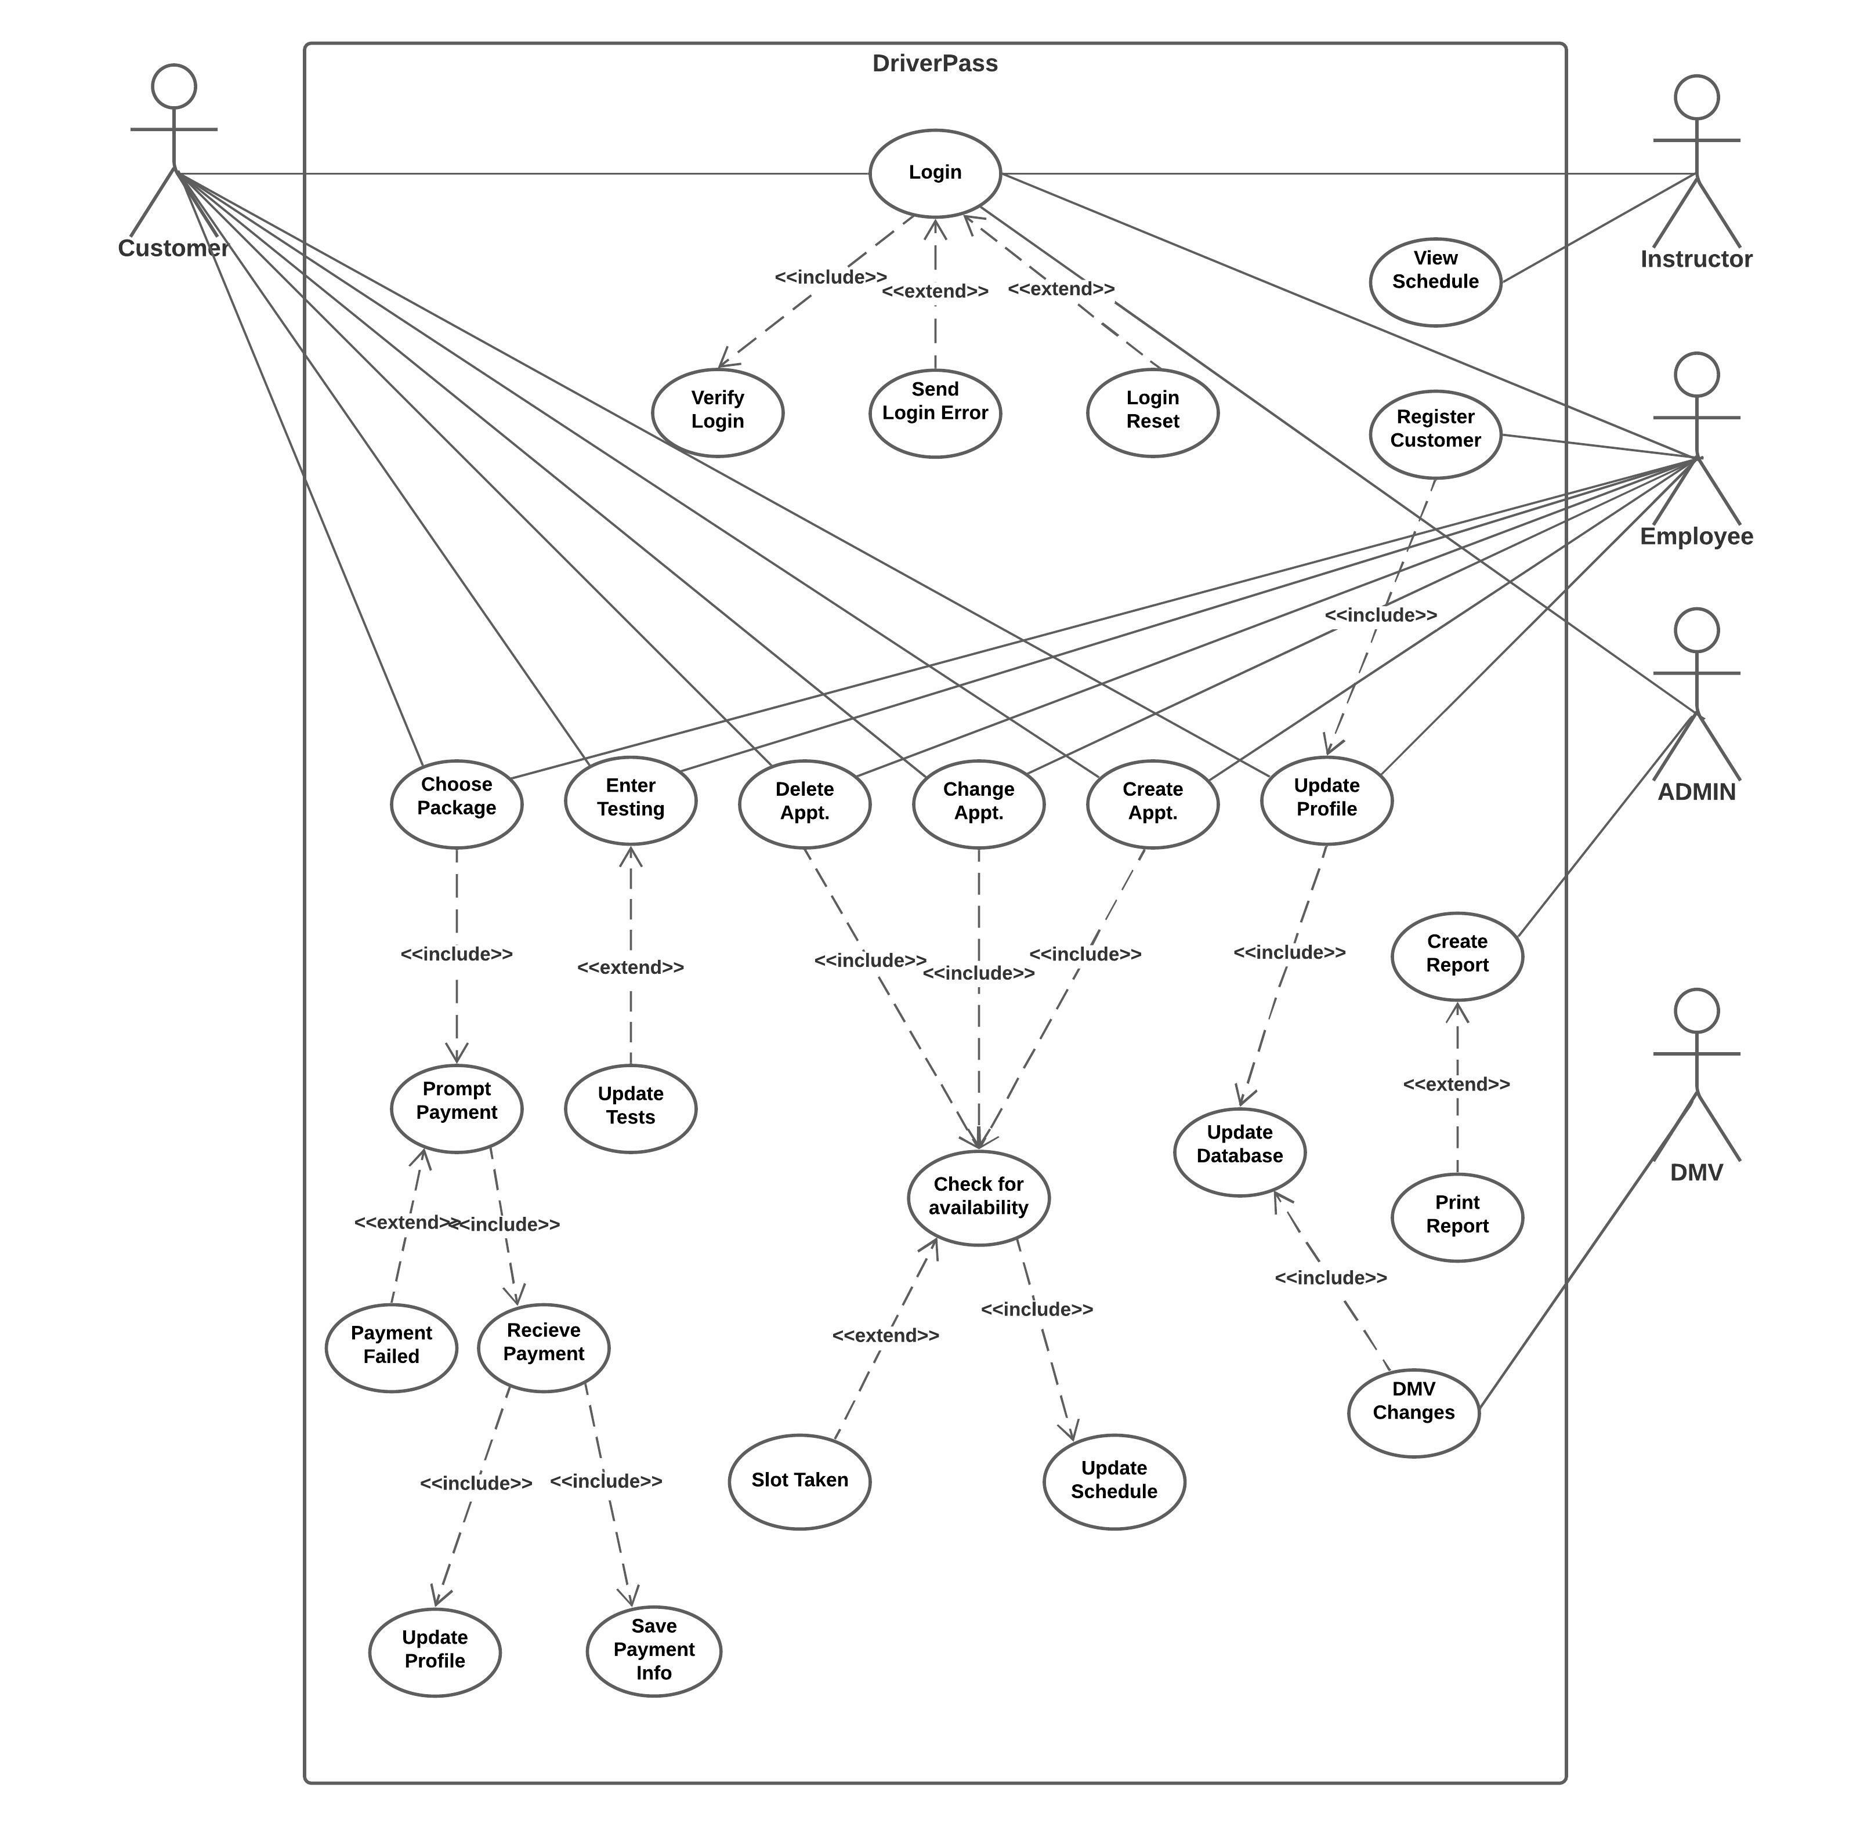

### UML Activity Diagrams

**Activity Diagram for User Login**

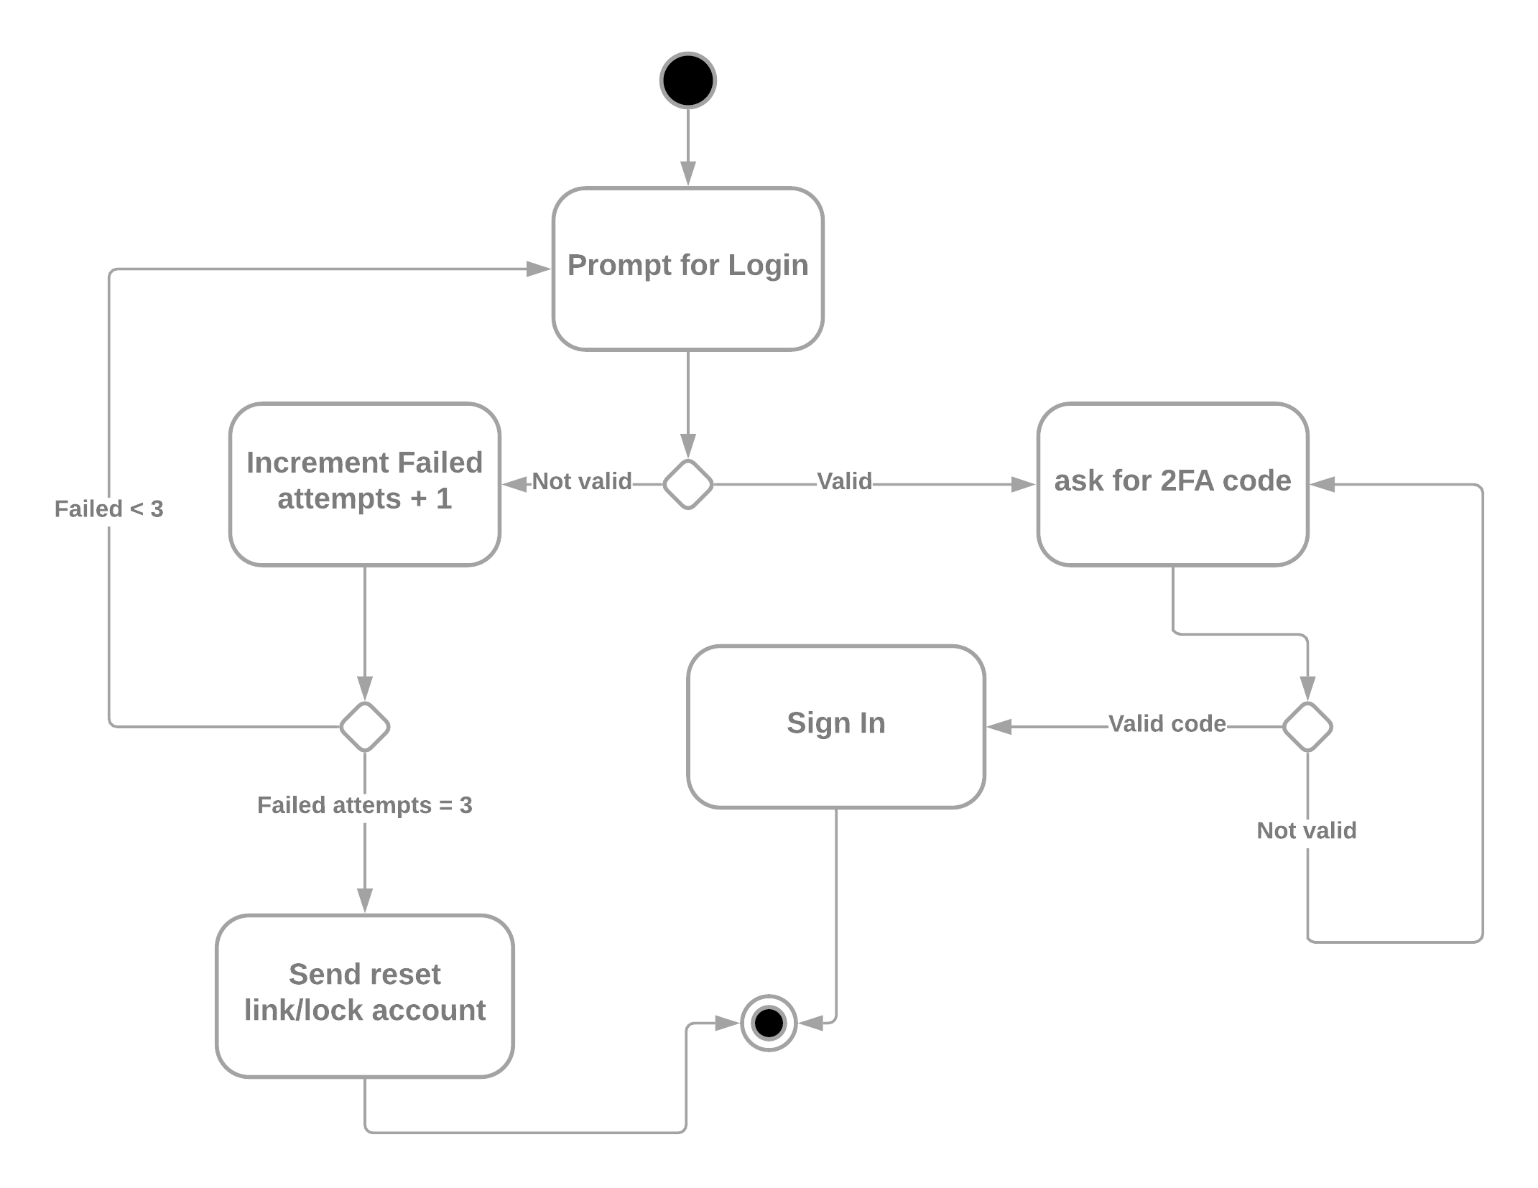

**Activity Diagram for user account creation and actions**

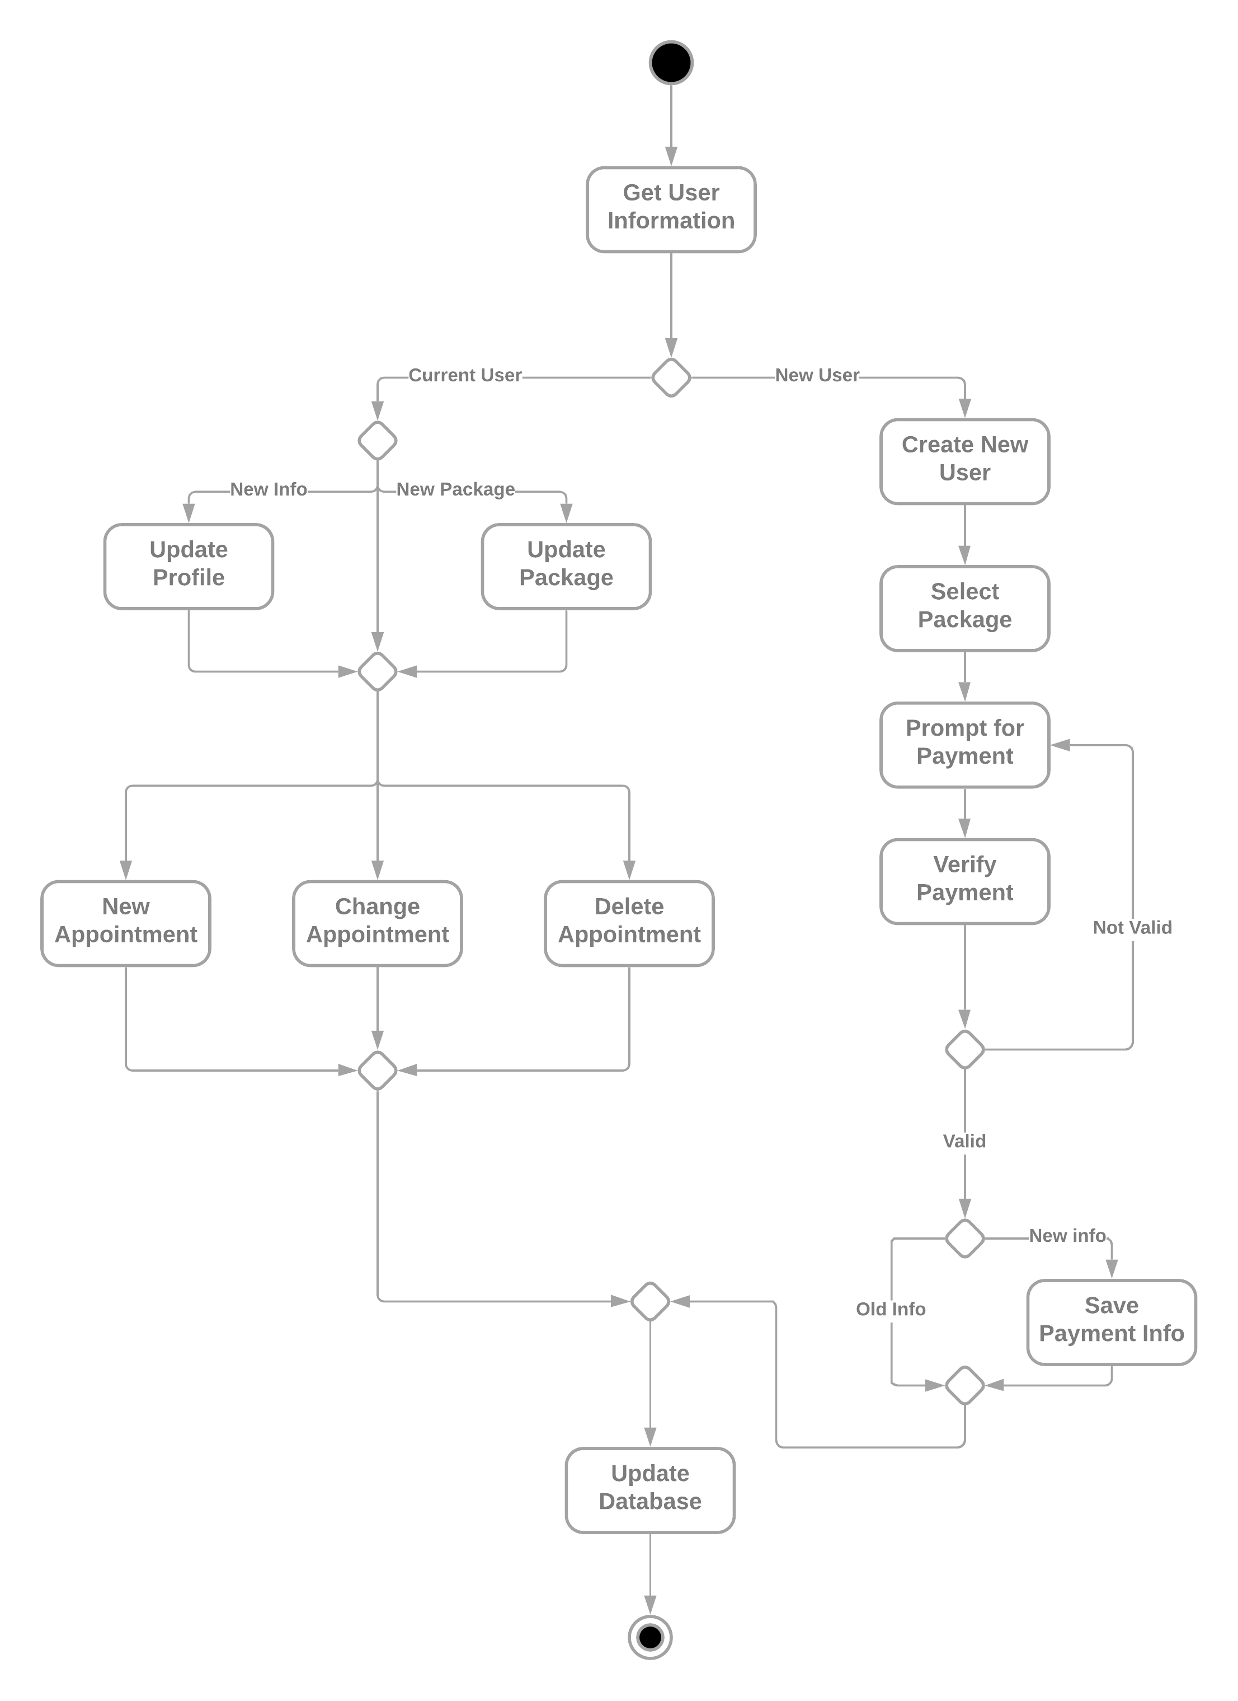

### UML Sequence Diagram

**UML Sequence Diagram for User Login**

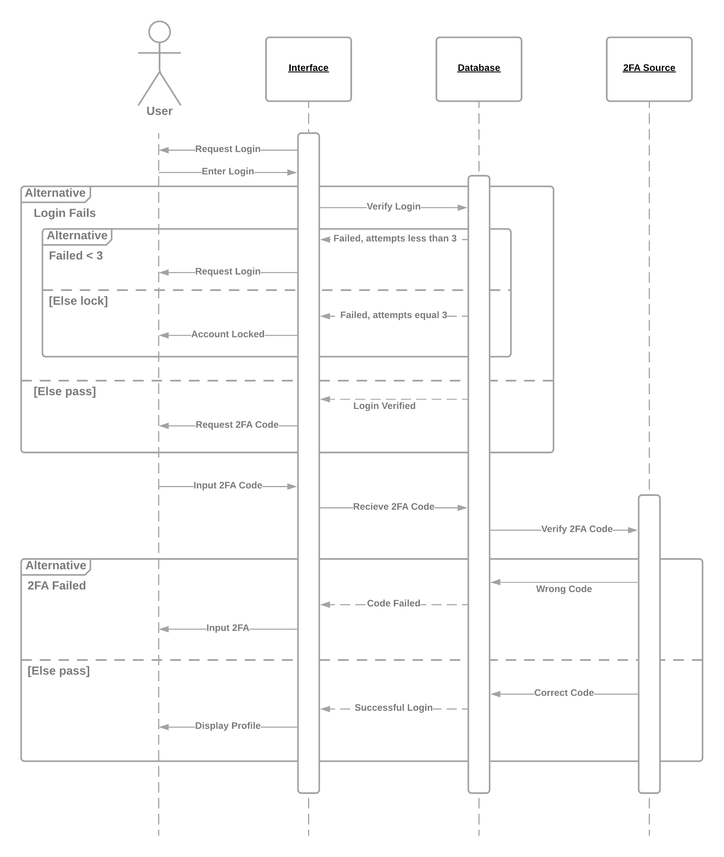

### UML Class Diagram

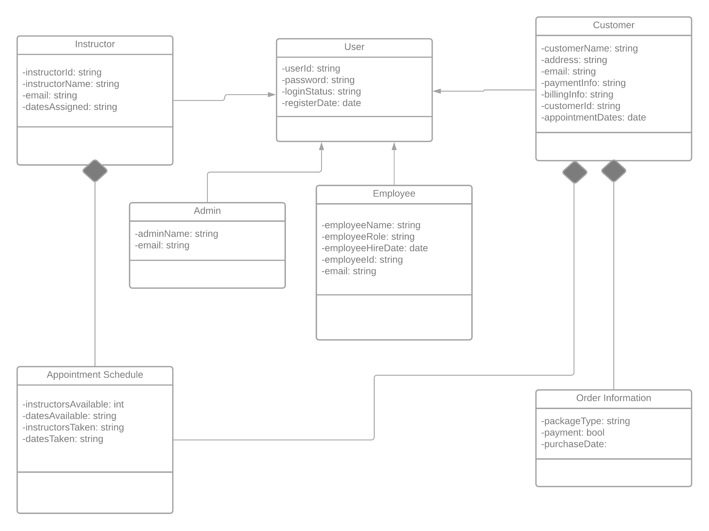

## Technical Requirements

1. Hardware
   1. Computers
   2. Peripherals
   3. Internet Connection/routers
2. Software
   1. Database to store information
   2. Updated OS
3. Geographical Information and Other
   1. Location of the system
   2. Location of DMV offices

Since the system is hosted completely online with security and other factors being handled the only “software” piece required would be the database to store information. Location of DMV offices should be an important consideration because of rules changing per region. Hardware comes down to basic peripherals.